Smoke Alarm
The alarm is set off when smoke enters its plastic case.

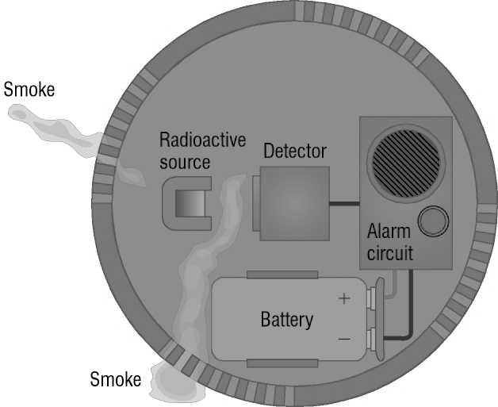

Put the sentences A–E below in the correct order to explain why smoke sets the alarm off.

A Detector signal falls.
B Smoke absorbs the radiation from the radioactive source.
C Radiation from the radioactive source reaches the detector.
D The drop in the detector signal activates the alarm circuit.
E A small green light flashes to show correct working.
……………………………………………………………………………
The Smoke Detector
(Solution)

C Radiation from the radioactive source reaches the detector.
E A small green light flashes to show correct working.
B Smoke absorbs the radiation from the radioactive source.
A Detector signal falls.
D The drop in the detector signal activates the alarm circuit.

